**CP Club 365 Days Challenge**

**Programming language – C++**

**Problem Statement**

<https://www.codechef.com/problems/ENDSORTED>

Git :- <https://github.com/Vedantbharad2603/CP_club_365_Days>

**Your Code**:

// 0x116Day of 0x365Days challenge

// VEDANT BHARAD

// 10-2-2023

//{ Driver Code Starts

#include <bits/stdc++.h>

using namespace std;

int findOne(int arr[], int n){

    for(int loop = 0; loop < n; loop++){

        if(arr[loop] == 1){

            return loop;}

    }

}

int findN(int arr[], int n){

    for(int loop = 0; loop < n; loop++){

        if(arr[loop] == n){

            return loop;}

    }

}

int myFun(int arr[], int n){

    int con=0;

    if(arr[0]!=1){

        int index=findOne(arr,n);

        while(arr[0]!=1){

            swap(arr[index-1],arr[index]);

            index--;

            con++;}

    }

    if(arr[n-1]!=n){

        int index=findN(arr,n);

        while(arr[n-1]!=n){

            swap(arr[index],arr[index+1]);

            index++;

            con++;}

    }

    return con;

}

int main() {

    int t;

    cin>>t;

    while(t--){

        int n;

        cin>>n;

        int arr[n];

        for(int i=0; i<n; i++){

            int temp;

            cin>>temp;

            arr[i] = temp;}

        cout<<myFun(arr, n)<<endl;

    }

    return 0;

}

**Output (Screen Shot)**:

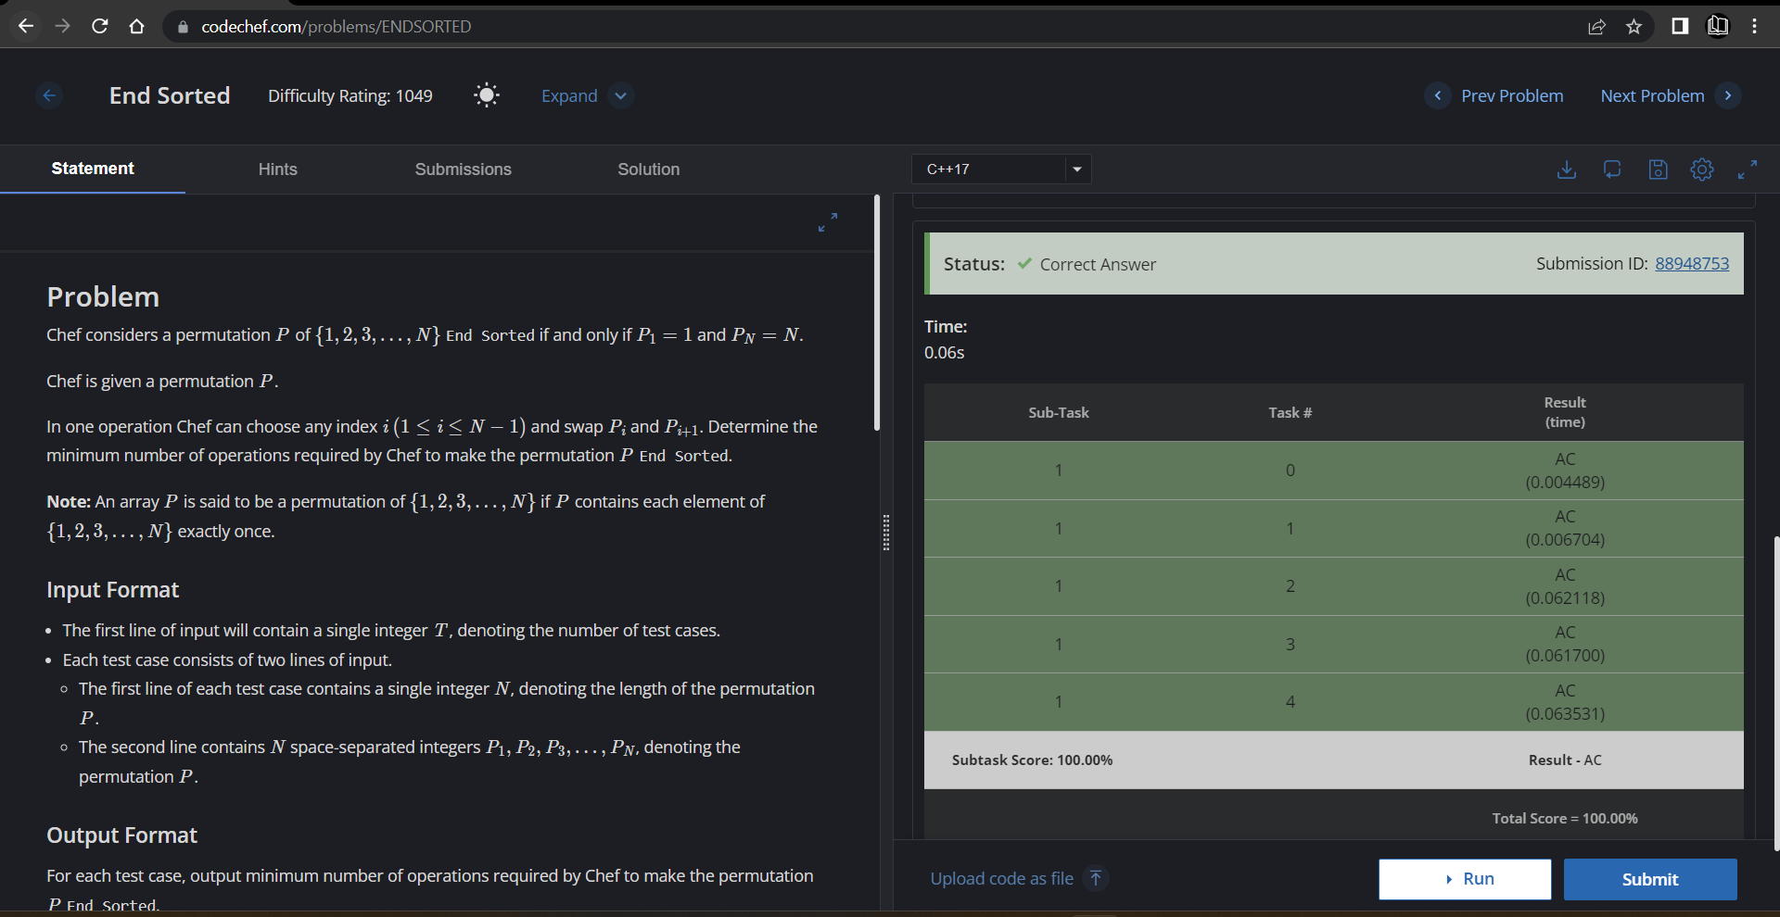

**Understanding about problem:**

* In this task I need to find whether the array is end sorted or not if it is then return 0 else make end sorted and return steps to make it end sorted.

Note: If you can't understand the problem, feel free to contact us and we'll help you. Please don't copy and paste from anywhere.

ALL THE BEST

Team CP Club